**OSINT**

**OSINT** stands for **Open Source Intelligence**. It refers to the process of collecting and analyzing information from publicly available sources to produce actionable intelligence. This type of intelligence gathering is widely used in various fields, including government, military, law enforcement, and cybersecurity.

**VULNARABILTY SCAN**

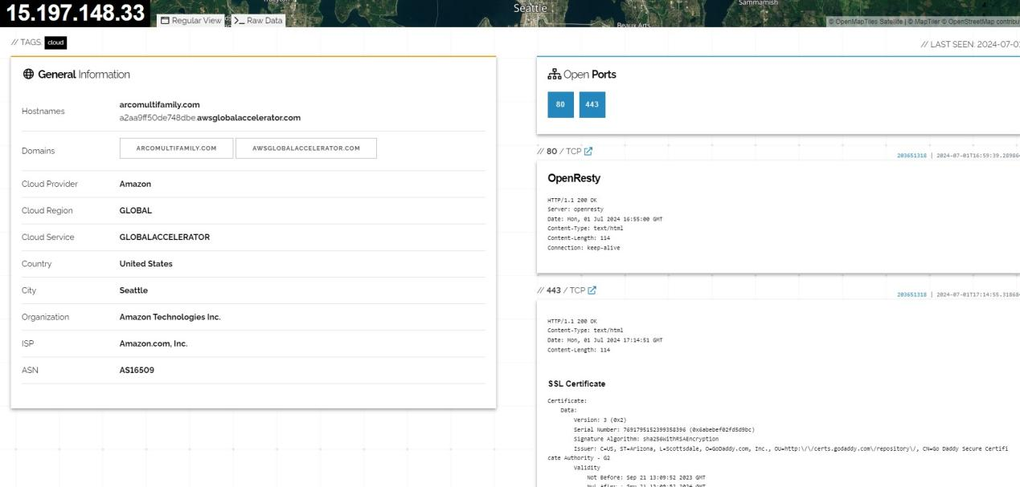

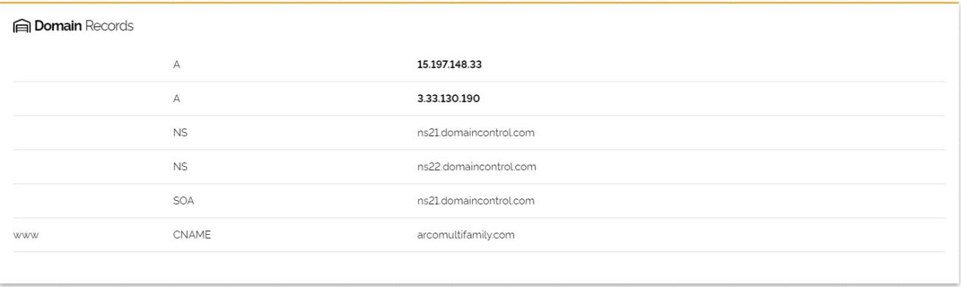

**Google Droks**

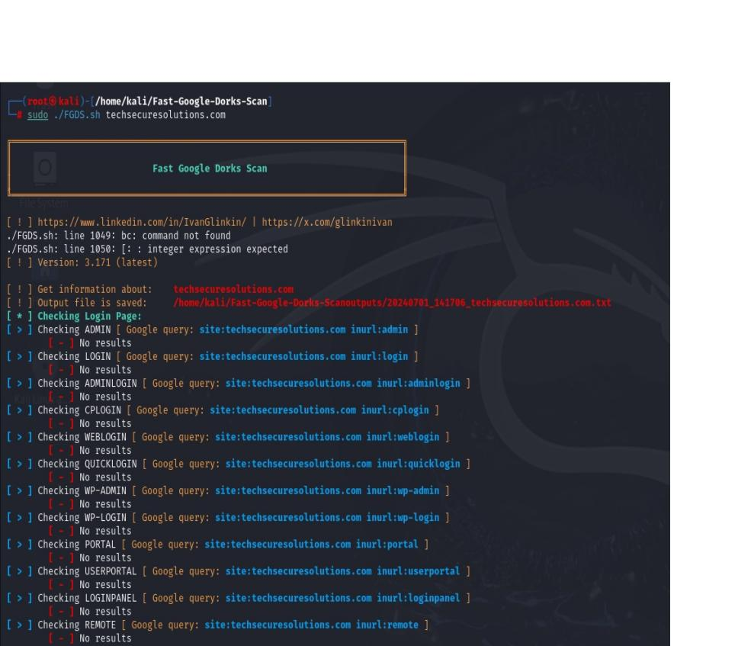

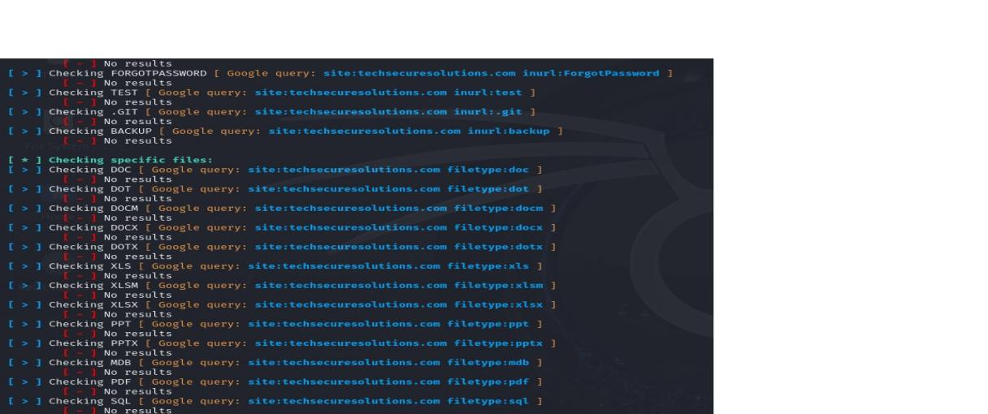

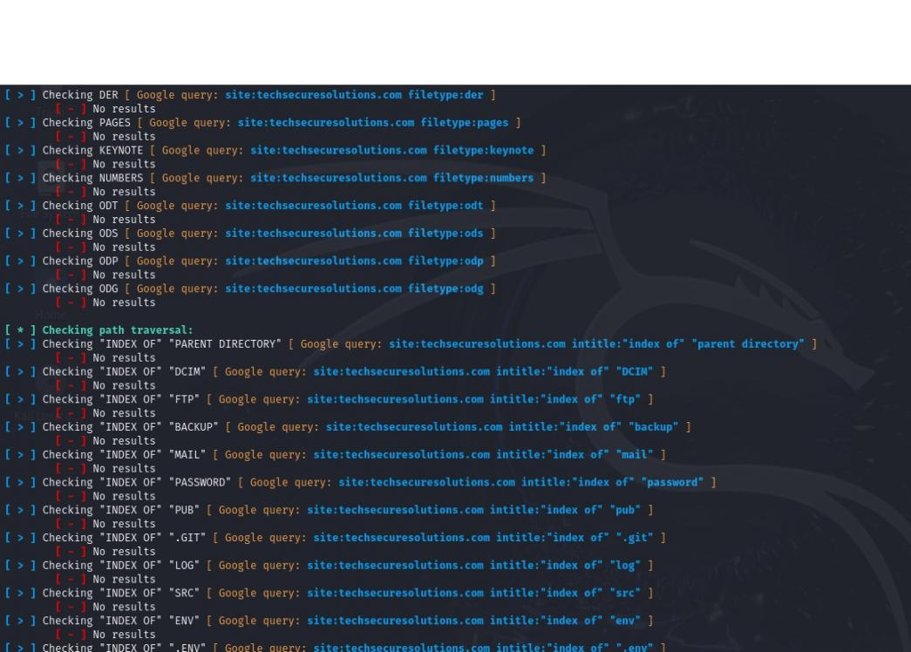

**DOMAIN INFO**

